**IOT BASED PARALYSIS PATIENT HEALTH CARE**

A Report

Submitted in the partial fulfilment of the requirement for the Degree of **Bachelor of Technology**

In

# **ELECTRONICS AND COMMUNICATION ENGINEERING**

**Presented By**: Group-39

Aman Gupta (2020041026)

Akash Singh (2020041022)

Abhishek Singh (2020041009)

Akash Singh (2020041023)

Under the supervision of:

**Dr. Gagan Deep Bharti**

**Assistant Professor**



# **DEPARTMENT OF ELECTRONICS AND COMMUNICATION ENGINEEERING**

**Madan Mohan Malaviya University of Technology, Gorakhpur (U.P.) - INDIA**

**May, 2024**

**CERTIFICATE**

This is to certify that the project report entitled “**IOT BASED PARALYSIS PATIENT HEALTH CARE”** submitted by Aman Gupta (2020041026), Akash Singh (2020041022), Abhishek Singh (2020041009), Akash Singh (2020041023) in partial fulfilment of the requirements for the award of B.Tech Degree in Electronics and Communication Engineering at the Madan Mohan Malaviya University of Technology, Gorakhpur is an authentic work carried out by them under my supervision and guidance.

To the best of my knowledge, the matter embodied in the report has not been submitted to any other University/Institute for the award of any Degree.

**Date:** 13/05/2024 Signature of the Supervisor

# **Dr. Gagan Deep Bharti**

# **Assistant Professor**

**Electronics and Communication Engineering Department**

# **ACKNOWLEDGEMENT**

Every project, big or small, is successful largely due to the efforts of a number of people who have always given their valuable advice or lent a helping hand. We sincerely appreciate the inspiration, support, and guidance of all those people who have been instrumental in making this project a success. We wish to express a sense of gratitude to our guide **Dr. Gagan Deep Bharti, Assistant professor, Electronics and Communication Engineering Department, Madan Mohan Malaviya University of Technology Gorakhpur,** to give us guidance at every moment during our entire project and giving valuable suggestions. His continuous encouragement at each work and effort to push the work through are gratefully acknowledged.

We are also very grateful to our classmates, for their huge co-operation and valuable suggestion from time to time during our entire project work. We also extend our gratitude to all members of the department without whose support at various stages this report will not be materialized. Finally we wish to thank our friends of B. Tech. 8th semester and seniors who helped us directly or indirectly in the successful completion of this work.

**Date**: 21/05/2024

**Place**: Gorakhpur

Aman Gupta (2020041026)

Akash Singh (2020041022)

Abhishek Singh (2020041009)

Akash Singh (2020041023)

# **ABSTRACT**

The IoT-based Paralysis Patient Healthcare System represents a significant advancement in healthcare technology, designed to empower individuals with paralysis by enabling seamless communication with medical professionals and caregivers. Central to this system is a sophisticated microcontroller-based architecture that integrates hand motion recognition circuitry and dedicated transmitter and receiver circuits. Utilizing advanced accelerometer and gyroscopic technologies, the hand motion recognition circuitry accurately detects and interprets hand movements, converting them into actionable commands.

These commands are wirelessly transmitted via RF signals to a receiver system, which processes and displays them on an intuitive LCD interface. Moreover, the system leverages IoT connectivity by transmitting data to the IoT Gecko server, allowing real-time access for healthcare providers and loved ones. This connectivity facilitates prompt responses and comprehensive care, transcending physical limitations to provide patients with a means of communicating needs, emergencies, and updates. By seamlessly merging hardware with IoT capabilities, this innovative system enhances patient autonomy and streamlines healthcare processes, fostering a more connected and responsive medical ecosystem.

The IoT-based Paralysis Patient Healthcare System heralds a transformative shift in healthcare technology, promising improved patient care and communication.

# **LIST OF FIGURES**

|  |  |
| --- | --- |
| **FIGURE NUMBER** | **DESCRIPTION** |
| **Figure 2.1.** | Schematic diagram of the Transmitter |
| **Figure 2.2.** | Schematic diagram of the Receiver |
| **Figure 2.3.** | ATmega328P (Arduino Board R3 UNO) |
| **Figure 2.4.** | MPU6050 Accelerometer Sensor |
| **Figure 2.5.** | ESP-01 ESP8266-01 Wi-fi Transceiver Module |
| **Figure 2.6.** | 2.4GHz NRF24L01+PA+LNA SMA Wireless Transceiver Antenna |
| **Figure 2.7.** | Original JHD 16×4 Character LCD Display with Yellow Backlight |
| **Figure 2.8.** | Hardware design of TRANSMITTER |
| **Figure 2.9.** | Hardware design of RECEIVER |

|  |  |  |
| --- | --- | --- |
|  | **TABLE OF CONTENTS** |  |
|  | Page No. |
| Certificate  Approval Sheet |  | ii  iii |
| Acknowledgement |  | iv |
| Abstract |  | v |
| List of Figures |  | vi |

Table of Contents vii-viii

**CHAPTER 1. INTRODUCTION 1-2**

* 1. System Architecture 1
  2. Hand Motion Recognition 1
  3. Wireless Communication 1
  4. Receiver System 1
  5. IoT Connectivity…... 1
  6. Remote Accessibility……………………………………………… 1
  7. Empowerment and Autonomy...……...……………………………………2
  8. Contemporary Innovations…………………………………………… …...2
  9. Integration of Hardware and IoT ………………………………………….2

**CHAPTER 2. OBJECTIVES 3-8**

* 1. SYSTEM ARCHITECTURE 3-4
     1. TRANSMITTER 3
     2. RECEIVER 3-4
  2. DESCRIPTION OF EACH COMPONENT 4-7
     1. Microcontroller: Arduino UNO ATmega328P 4
     2. MPU 6050 Accelerometer 5
     3. ESP-01 ESP8266-01 Transceiver 6
     4. RF Transmitter and Receiver (nrf24L01) 6-7
     5. Original JHD 16*4 Character LCD 7-8
  3. HARDWARE DESIGN 8
     1. Hardware design of Transmitter 8
     2. Hardware design of Receiver 8

**CHAPTER 3. LITERATURE REVIEW 9-10**

* 1. HISTORY 9-10

3.1.1 Early Developments 9

3.1.2 Emergence of IoT and Healthcare 9

3.1.3 Advances in Sensor Technology 9-10

* 1. PREVIOUS RELATED WORK AND RELATED TECHNOLOGY 10

3.2.1 Wearable Sensors for Health Monitoring 10

3.2.2 Remote Patient Monitoring Systems 10

3.2.3 RF Communication in Healthcare Devices 10

3.2.4 IoT-Based Health Monitoring Systems 10

3.2.5 Hand Gesture Recognition Using Accelerometers 10

**CHAPTER 4. BENEFITS, CHALLENGES & FUTURE ENHANCEMENTS 11-12**

* 1. BENEFITS 11
  2. CHALLENGES FACED 12
  3. FUTURE ENHANCEMENTS 12

**CHAPTER 5. CONCLUSION 13**

**APPENDICES 14-18**

**REFERENCES 19**

**CHAPTER 1.**

**INTRODUCTION**

* 1. **System Architecture**

At the heart of this innovative system is a sophisticated microcontroller-based architecture. This architecture integrates several key components, including hand motion recognition circuitry and dedicated transmitter and receiver circuits. These elements work together to create a cohesive and responsive communication system for patients.

* 1. **Hand Motion Recognition**

Central to the system’s functionality is the hand motion recognition circuitry. This component utilizes advanced accelerometer and gyroscopic technologies to detect and interpret nuanced hand movements. By translating these movements into actionable commands, the system allows patients to communicate effectively despite physical limitations.

* 1. **Wireless Communication**

The interpreted commands are then wirelessly transmitted via RF signals to the receiver system. This wireless communication ensures that the system remains user-friendly and accessible, without the need for cumbersome wiring or complex interfaces.

* 1. **Receiver System**

The receiver system acts as the nerve center of the setup, processing incoming commands with precision. It displays these commands on an intuitive LCD interface, ensuring that caregivers and medical professionals can easily understand and respond to the patient’s needs.

* 1. **IoT Connectivity**

A significant advancement in the system is its integration with IoT technology. The receiver system transmits the processed data to the IoT Gecko server via online channels. This connectivity allows for real-time data access, enabling doctors, nurses, and concerned loved ones to monitor the patient's condition remotely.

* 1. **Remote Accessibility**

The IoT server serves as a crucial bridge, making vital patient information accessible over the internet. This feature ensures that medical professionals can provide prompt responses and holistic care, even from a distance, thereby improving the overall efficiency of the healthcare process.

* 1. **Empowerment and Autonomy**

This system transcends the physical barriers imposed by paralysis, giving patients a new means of expressing their needs, emergencies, or general updates. By enabling this level of communication, the system significantly enhances patient autonomy and quality of life.

* 1. **Contemporary Innovations**

Recent innovations have focused on improving the user interface and overall system reliability. The development of intuitive LCD interfaces has made it easier for patients and caregivers to interact with the system. Furthermore, ongoing research aims to enhance the accuracy of motion recognition algorithms, reduce power consumption, and ensure robust data security and privacy.

* 1. **Integration of Hardware and IoT**

The seamless integration of hardware and IoT capabilities is a key strength of this system. By combining these technologies, the system not only improves patient autonomy but also streamlines healthcare processes, making the medical ecosystem more connected and responsive.

**CHAPTER 2.**

**OBJECTIVES**

* 1. **SYSTEM ARCHITECTURE**
     1. **TRANSMITTER**

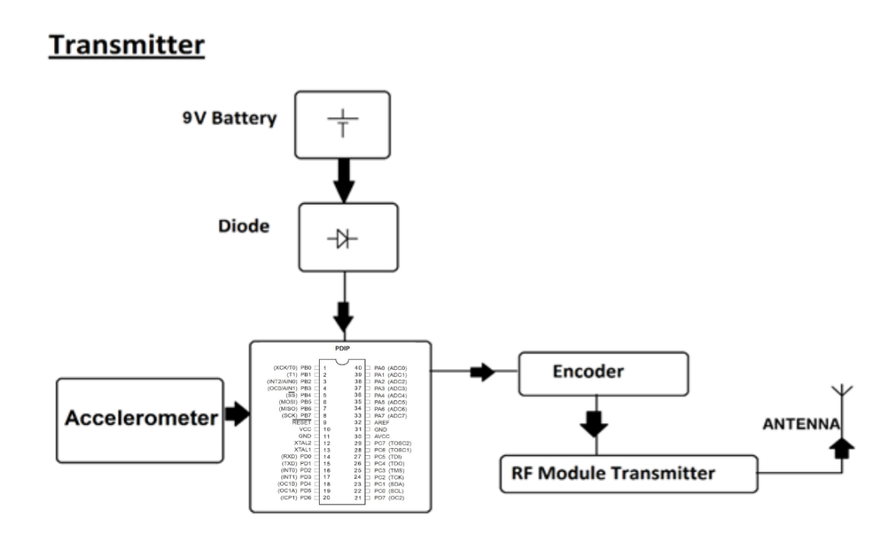The transmitter section of the IoT-based Paralysis Patient Healthcare System plays a critical role in ensuring seamless communication between the patient and the receiver system. Utilizing advanced RF (radio frequency) technology, the transmitter captures the commands generated by the hand motion recognition circuitry. These commands, derived from interpreting nuanced hand movements, are encoded into RF signals. The transmitter then wirelessly sends these signals to the receiver system. This wireless transmission ensures that data is relayed quickly and reliably, without the need for physical connections, thus enhancing the system's usability and efficiency in providing timely responses to the patient's needs.

**Figure 2.1.** Transmitter

* + 1. **RECEIVER**

The receiver section of the IoT-based Paralysis Patient Healthcare System is the nerve center that processes incoming RF signals from the transmitter. It decodes these signals, which contain commands derived from the patient's hand movements, and displays the information on an intuitive LCD interface. This allows caregivers and medical professionals to quickly understand and respond to the patient’s needs. Additionally, the receiver integrates IoT connectivity, transmitting the decoded data to the IoT server. This real-time data sharing ensures that healthcare providers can monitor and assist the patient remotely, fostering a **A diagram of a circuit board
**more responsive and connected healthcare environment.

**Figure 2.2.** Receiver

* 1. **DESCRIPTION OF EACH COMPONENT**
     1. **Microcontroller: ATmega328P (Arduino Board R3 UNO)**

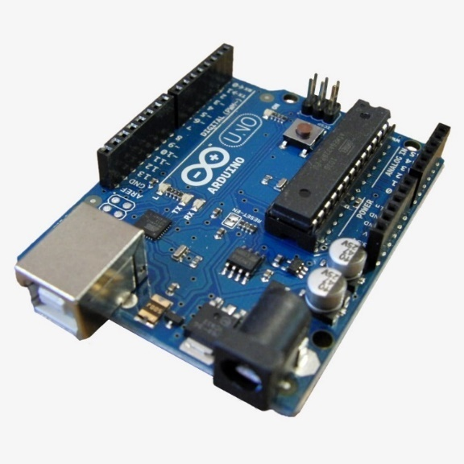Arduino UNO is a microcontroller board based on the **ATmega328P**. It has 14 digital input/output pins (of which 6 can be used as PWM outputs), 6 analog inputs, a 16 MHz ceramic resonator, a USB connection, a power jack, an ICSP header and a reset button. It contains everything needed to support the microcontroller; simply connect it to a computer with a USB cable or power it with a AC-to-DC adapter or battery to get started.

**Figure 2.3. ATmega328P (Arduino Board R3 UNO)**

* + 1. **MPU 6050 Accelerometer Sensor**

The MPU-6050 accelerometer sensor is a widely used motion tracking device that integrates a 3-axis accelerometer and a 3-axis gyroscope into a single chip. It is known for its high performance, small size, and affordability, making it a popular choice for various applications, including robotics, smartphones, gaming devices, and IoT projects.

The MPU-6050 operates on the principle of microelectromechanical systems (MEMS), detecting changes in motion, orientation, and acceleration. The accelerometer component measures linear acceleration along the X, Y, and Z axes, providing data on the sensor's movement and positioning in three-dimensional space. Simultaneously, the gyroscope measures rotational velocity around the same three axes, offering insights into the angular motion.

One of the key features of the MPU-6050 is its Digital Motion Processor (DMP), which allows complex motion processing algorithms to run directly on the sensor. This offloads the main microcontroller, leading to more efficient processing and reduced power consumption. The sensor communicates with microcontrollers via I2C or SPI interfaces, ensuring compatibility with a wide range of systems.

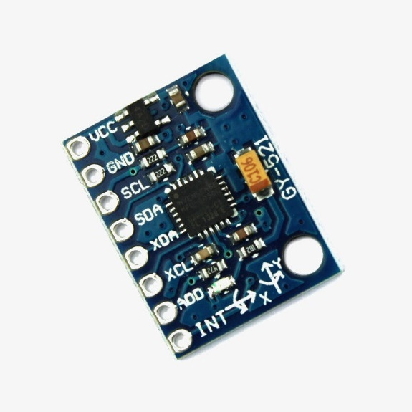In the context of the IoT-based Paralysis Patient Healthcare System, the MPU-6050 plays a crucial role in the hand motion recognition circuitry. It accurately detects and interprets the nuanced hand movements of the patient, converting them into actionable commands that are transmitted to the receiver system. This enables patients to communicate effectively despite physical limitations, enhancing their autonomy and improving their quality of life.

**Figure 2.4. MPU6050 Accelerometer Sensor**

* + 1. **ESP-01 ESP8266-01 Wi-fi Transceiver Module**

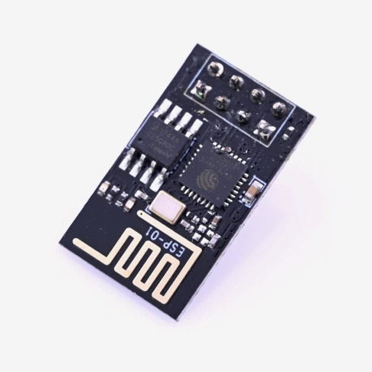The ESP-01 ESP8266-01 Wi-Fi transceiver module is a compact and powerful component used to add Wi-Fi connectivity to various electronic projects. Featuring the ESP8266 chip, it provides a reliable and cost-effective solution for wireless communication. The module supports TCP/IP protocol stacks, making it ideal for IoT applications. With its ability to operate in both station and access point modes, the ESP-01 can connect to a Wi-Fi network or create its own. It communicates with microcontrollers via UART, simplifying integration. In the IoT-based Paralysis Patient Healthcare System, the ESP-01 facilitates real-time data transmission to remote servers, enabling effective patient monitoring and care.

**Figure 2.5. ESP-01 ESP8266-01 Wi-fi Transceiver Module**

* + 1. **RF Transmitter and Receiver (2.4GHz NRF24L01+PA+LNA SMA Wireless Transceiver Antenna)**

The NRF24L01 module is the latest in RF modules. This module uses the 2.4GHz transceiver from ***Nordic Semiconductor***, the NRF24L01+. This transceiver IC operates in the 2.4GHz band and has many new features! Take all the coolness of the 2.4GHz NRF24L01+PA+LNA SMA Wireless [Transceiver](https://robu.in/product-tag/transceiver/) Antenna and add some extra pipelines, buffers, and an auto-retransmit feature.

**Figure 2.6. 2.4GHz NRF24L01+PA+LNA SMA Wireless Transceiver Antenna**

**This board features a reverse polarized SMA connector for maximum**[RF](https://robu.in/product-category/wireless/rf-module/)**range. And there is PA and LNA circuit on board, with the external antenna it can reach long distance than the one without these parts.**

**This module comes with the 2.4G**[antenna](https://robu.in/product-category/fpv-telemetry-remote/antena/)**(2DB), with a 250Kbps transmission rate on open-air it can reach the 800-1K meters communication device.**

* + 1. **Original JHD 16×4 Character LCD Display with Yellow Backlight**

If you want to add some visual output to your Arduino projects, you’ll need a [display](https://robu.in/product-category/led-lcd-and-display-boards/). If you need only a little to [display](https://robu.in/product-category/led-lcd-and-display-boards/), the LCD 16×4 Parallel [LCD Display](https://robu.in/product-category/led-lcd-and-display-boards/lcd-display/) is a quite good solution.

This is LCD 16×4 Parallel LCD Display that provides a simple and cost-effective solution for adding a 16×4 Black on RGB Liquid Crystal Display into your project. **The display is a 16 character by 4-line display that has a very clear and high contrast black text upon a yellow background/backlight.** This is the great Original JHD 16×4 Character [LCD display](https://robu.in/product-category/led-lcd-and-display-boards/lcd-display/) With Yellow Backlight. It is fantastic for an Arduino-based project. This LCD 16×4 Parallel LCD Display with Yellow Backlight is very easy to interface with [Arduino](https://robu.in/product-category/arduino-2/arduino/) or [Other Microcontrollers.](https://robu.in/product-category/development-board/)

**Figure 2.7. Original JHD 16×4 Character LCD Display with Yellow Backlight**

* 1. **HARDWARE DESIGN**
     1. 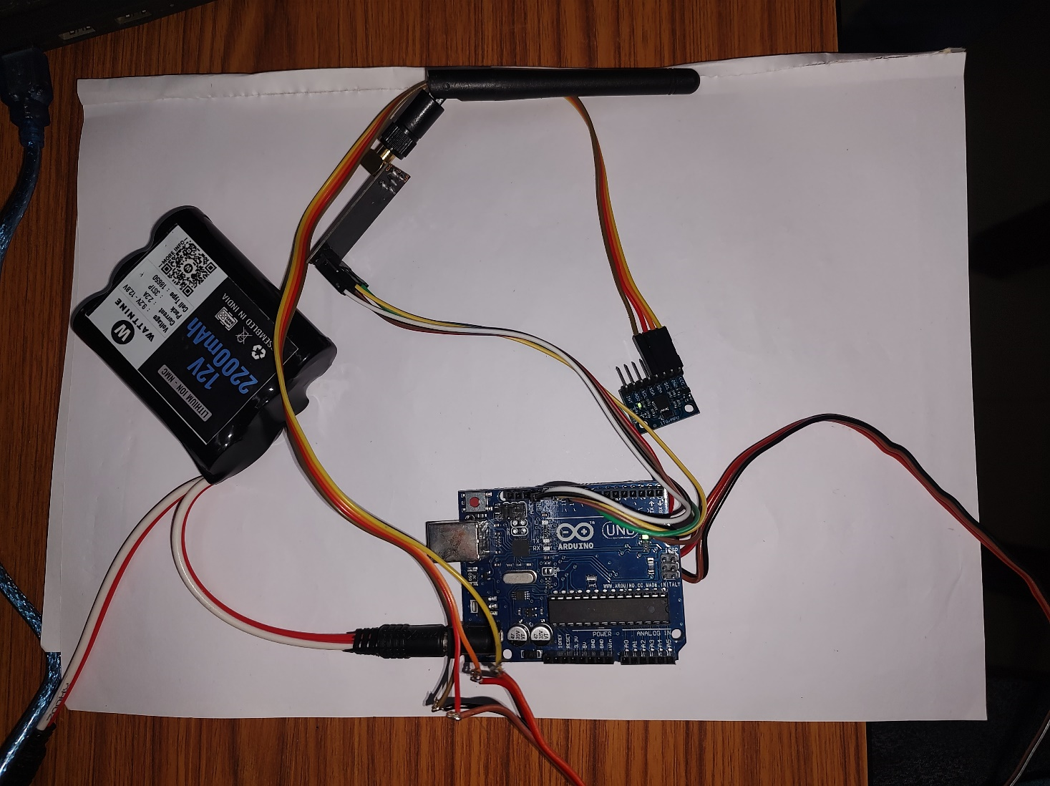**HARDWARE DESIGN OF TRANSMITTER**

**Figure 2.8. Hardware design of TRANSMITTER**

* + 1. **HARDWARE DESIGN OF RECEIVER**

**Figure 2.9. Hardware design of RECEIVER**

**CHAPTER 3.**

**LITERATURE REVIEW**

* 1. **HISTORY**

The integration of Internet of Things (IoT) technologies into healthcare systems has evolved significantly over the past few decades, marking considerable advancements in patient care, particularly for individuals with paralysis. Historically, the journey of IoT-based healthcare solutions has been influenced by the convergence of various technological developments, patient needs, and innovative research efforts.[4]

* + 1. **Early Developments**

In the early stages, healthcare systems for paralysis patients primarily focused on rudimentary assistive devices. These devices were often mechanical and provided basic functionalities such as mobility aids (e.g., wheelchairs) and simple communication tools. The advent of digital technology in the late 20th century began to shift this paradigm, introducing more sophisticated electronic devices that could offer better support and communication options.[4]

* + 1. **Emergence of IoT and Healthcare**

The concept of IoT emerged in the early 2000s, revolutionizing various sectors, including healthcare. Researchers began to explore the potential of interconnected devices to enhance medical care. Initial applications in healthcare included remote monitoring systems that allowed for continuous patient observation without the need for constant physical presence by healthcare providers. These systems primarily focused on chronic disease management, elderly care, and post-operative monitoring.[1]

* + 1. **Advances in Sensor Technology**

The development of advanced sensor technologies, such as accelerometers and gyroscopes, played a pivotal role in enhancing IoT-based healthcare systems. Accelerometers and gyroscopes, initially developed for consumer electronics and industrial applications, found new use cases in healthcare by providing accurate motion detection and orientation data. This enabled the creation of more responsive and interactive assistive devices.[3]

* 1. **PREVIOUS WORKS AND RELATED TECHNOLOGIES**
     1. **Wearable Sensors for Health Monitoring**

Wearable sensors have been instrumental in the development of IoT-based health monitoring systems. These devices, which often include accelerometers and gyroscopes, can track a variety of health metrics, and transmit data in real-time.[1]

* + 1. **Remote Patient Monitoring Systems**

Remote patient monitoring (RPM) systems have laid the groundwork for IoT-based healthcare by allowing continuous monitoring of patients' vital signs and movements, facilitating early intervention and personalized care.[4]

* + 1. **RF Communication in Healthcare Devices**

The use of RF communication technology in healthcare devices has enabled wireless data transmission, enhancing the mobility and convenience of medical monitoring systems.[4]

* + 1. **IoT-Based Health Monitoring Systems**

Recent studies have explored the integration of IoT platforms with health monitoring systems, focusing on real-time data access and enhanced patient care.[5]

* + 1. **Hand Gesture Recognition Using Accelerometers**

Research in hand gesture recognition using accelerometers has contributed significantly to the development of assistive technologies for individuals with motor impairments.[3]

**CHAPTER.4**

**BENEFITS, CHALLENGES AND FUTURE ENHANCEMENTS**

* 1. **Benefits**
     1. **Enhanced Communication and Autonomy**

Empowers paralysis patients to convey messages and needs effectively using hand gestures. Provides a means for patients to communicate independently, fostering a sense of autonomy and control over their healthcare needs.

* + 1. **Efficient Healthcare Communication**

Facilitates seamless communication between patients and healthcare providers or caregivers. Enables swift transmission of critical information, reducing response times in emergencies and enhancing overall healthcare efficiency.

* + 1. **Remote Monitoring and Support**

Allows remote monitoring of patients' conditions by doctors, nurses, or family members through the IoT server. Offers real-time updates and alerts, enabling timely intervention or support from anywhere with internet access.

* + 1. **Improved Quality of Care**

Enhances the quality of care by providing a direct and immediate channel for patients to express their needs or emergencies. Enables healthcare professionals and caregivers to respond promptly and effectively to patients' requirements.

* + 1. **Increased Patient Comfort and Confidence**

Promotes a more comfortable and confident experience for patients by offering a user-friendly communication system. Reduces anxiety by ensuring patients that their messages and needs are conveyed accurately and promptly.

* + 1. **Streamlined Healthcare Processes**

Optimizes healthcare processes by integrating technology to streamline communication between patients and healthcare providers. Reduces manual intervention and potential errors in relaying messages or interpreting patient needs.

The IoT-based paralysis patient healthcare system not only revolutionizes communication for patients with limited mobility but also significantly impacts the efficiency, quality, and responsiveness of healthcare services, ultimately improving the overall patient experience and well-being.

* 1. **CHALLENGES** 
     1. **Accuracy and Calibration**

Ensuring precise calibration of the hand motion recognition system for accurate interpretation of gestures can be challenging.

* + 1. **Wireless Connectivity**

Maintaining consistent and reliable wireless connectivity between the transmitter and receiver over longer distances.

* + 1. **Integration Complexity**

Managing the integration of various hardware components and ensuring their seamless operation can pose challenges during development.

* 1. **FUTURE ENHANCEMENTS**
     1. **Advanced Gesture Recognition**

Implementing machine learning or AI algorithms for more advanced gesture recognition, enhancing accuracy and expanding gesture vocabulary.

* + 1. **IoT Platform Improvements**

Upgrading the IoT Gecko server for enhanced data visualization, analytics, and more interactive remote monitoring features.

* + 1. **Wearable Technology**

Developing wearable devices or smaller, more portable versions of the system for increased patient convenience and mobility.

* + 1. **Interactivity and Voice Integration**

Incorporating voice commands or touchless interfaces for patients with more severe mobility limitations.

* + 1. **Security Measures**

Enhancing system security to safeguard patient data and ensure privacy in data transmission over the internet.

**CHAPTER 5.**

**CONCLUSION**

The IoT-based Paralysis Patient Healthcare System signifies a transformative leap in healthcare technology, offering unprecedented opportunities for individuals with limited mobility. This innovative system integrates sophisticated hardware and advanced IoT functionalities, enabling seamless and efficient communication for patients. By harnessing gesture recognition technology, wireless transmission, and robust IoT connectivity, the system empowers patients to convey crucial messages to caregivers and healthcare providers effectively.

The successful implementation of this system demonstrates significant enhancements in patient autonomy, allowing individuals with paralysis to communicate their needs and conditions independently. This empowerment not only improves the quality of life for patients but also alleviates the burden on caregivers and healthcare professionals by providing real-time, accurate information that facilitates timely and appropriate responses.

The benefits of this system extend beyond individual patient care, highlighting its potential to streamline healthcare communication overall. By enabling instantaneous data transmission and real-time monitoring, the system ensures that healthcare providers can make informed decisions quickly, improving the overall efficiency and effectiveness of medical care.

Moreover, the system's ability to transmit data to IoT platforms like the IoT Gecko server paves the way for comprehensive health monitoring and data analysis. This connectivity supports continuous care and allows for the collection of extensive health data, which can be used to improve treatment plans, conduct research, and develop new healthcare strategies. Looking forward, the IoT-based Paralysis Patient Healthcare System sets the stage for future advancements in healthcare technology.

In conclusion, this system stands as a beacon of innovation, bridging significant gaps in healthcare accessibility. It exemplifies how technology can create more inclusive, responsive, and patient-centric solutions, ultimately fostering a healthcare environment where all individuals, regardless of their physical limitations, can receive the care and attention they need. The IoT-based Paralysis Patient Healthcare System not only addresses current challenges but also lays the groundwork for future innovations, promising a more connected and compassionate healthcare ecosystem.

**APPENDICES**

**SOFTWARE CODE**

**TRANSMITTER**

//Include Libraries

#include <SPI.h>

#include <nRF24L01.h>

#include <RF24.h>

#include <Adafruit_MPU6050.h>

#include <Wire.h>

#include <MPU6050.h>

MPU6050 mpu;

//create an RF24 object

RF24 radio(9, 8); // CE, CSN

//address through which two modules communicate.

const byte address[6] = "00001";

void setup() {

Serial.begin(9600);

Wire.begin();

mpu.initialize();

// You can adjust the sensitivity of the accelerometer by changing the following line

mpu.setFullScaleAccelRange(MPU6050_ACCEL_FS_2);

radio.begin();

//set the address

radio.openWritingPipe(address);

//Set module as transmitter

radio.stopListening();

}

void loop() {

int16_t ax, ay, az;

mpu.getAcceleration(&ax, &ay, &az);

// Calculate tilt angles

float roll = atan2(ay, az) * 180 / M_PI;

float pitch = atan2(-ax, sqrt(ay * ay + az * az)) * 180 / M_PI;

// Hysteresis thresholds

const int threshold = 30;

const int hysteresis = 5;

// Direction logic with hysteresis

static char lastDirection[] = "Level";

char direction[6];

strcpy(direction, "Level"); // Default direction

if (abs(roll) > threshold + hysteresis || (abs(roll) > threshold - hysteresis && strcmp(lastDirection, "Right") == 0 && roll > 0) || (abs(roll) > threshold - hysteresis && strcmp(lastDirection, "Left") == 0 && roll < 0)) {

if (roll > 0) {

static char Direction[] = "Right";

radio.write(&Direction, sizeof(Direction));

strcpy(direction, "Right");

} else {

static char Direction[] = "Left";

radio.write(&Direction, sizeof(Direction));

strcpy(direction, "Left");

}

} else if (abs(pitch) > threshold + hysteresis || (abs(pitch) > threshold - hysteresis && strcmp(lastDirection, "Down") == 0 && pitch > 0) || (abs(pitch) > threshold - hysteresis && strcmp(lastDirection, "Up") == 0 && pitch < 0)) {

if (pitch > 0) {

static char Direction[] = "Down";

radio.write(&Direction, sizeof(Direction));

strcpy(direction, "Down");

} else {

static char Direction[] = "Up";

radio.write(&Direction, sizeof(Direction));

strcpy(direction, "Up");

}

}

if (strcmp(lastDirection, direction) != 0) {

Serial.println(direction);

// radio.write(&Direction, sizeof(Direction));

strcpy(lastDirection, direction);

}

delay(1000);

}

**RECEIVER**

#include <SPI.h>

#include <nRF24L01.h>

#include <RF24.h>

#include <LiquidCrystal_I2C.h>

RF24 radio(9, 8); // CE, CSN

LiquidCrystal_I2C lcd(0x27, 16, 2);

const byte address[6] = "00001";

String str = "no data";

void setup() {

lcd.init(); // Initialize LCD with 16 columns and 2 rows

lcd.backlight();

Serial.begin(9600);

radio.begin();

radio.openReadingPipe(1, address);

radio.startListening();

lcd.setCursor(0, 0); // Set cursor to the first row

lcd.print(str);

}

void loop() {

if (radio.available()) {

char text[32] = { 0 };

radio.read(&text, sizeof(text));

Serial.println(text);

str = text;

if (str == "Left") {

lcd.setCursor(0, 0);

lcd.print("Washroom");

}

else if(str == "Right"){

lcd.setCursor(0, 0);

lcd.print("Water");

}

else if(str == "Up"){

lcd.setCursor(0, 0);

lcd.print("Food");

}

else {

lcd.setCursor(0, 0);

// lcd.setCursor(0, 1); // Set cursor to the first row

lcd.print("Medicine");

}

delay(500);

lcd.clear();

}

}

**REFERENCES**

* 1. Gadekar, Santosh, Gauri Kolpe, Gosavi Rutuja, Vaishnavi Fatate, Bhosale Bhosale, Shriprasad Chate, and Akshay Lad. "Arduino Uno-ATmega328 P Microcontroller Based Smart Systems." In *Proceedings of the 3rd International Conference on Communication & Information Processing (ICCIP)*. 2021.
  2. MACFOS. *How to Interface MPU6050 with the Arduino - Robu.in | Indian Online Store | RC Hobby | Robotics*. robu.in/mpu6050-with-arduino/.
  3. Dunbar, N. (2024). *Arduino interrupts: Harness the power of interrupts in your Arduino and ATmega328 code*. Apress.
  4. ReneeSegridReddiyar, Ms N., S. Remina, S. Sabrin, and M. Subhashini. "IoT Based Paralysis Patient Health Care Monitoring System." *Journal of University of Shanghai for Science and Technology* 23, no. 6 (2021).
  5. Design and Implementation of Fall Detection System Using MPU6050 Arduino

Inclusive Smart Cities and Digital Health, 2020, Volume 9677 ISBN: 978-3-319-39600-2 Ziad Tarik Al-Dahan, Nasseer K. Bachache, Lina Nasseer Bachache